**MANGALORE REFINERY AND PETROCHEMICALS LIMITED**

**(A Subsidiary of Oil and Natural Gas Corporation Limited)**

**ECONOMIC OVERVIEW**

Covid-19 pandemic made 2021 a unique year for the world. The global economy contracted to -3.3%. Lockdowns that impacted all business brought drastic change on macroeconomy that includes employment, consumption, investment, and savings. Global growth expected to rise 5% in FY 2021 aided by fiscal support and vaccine powered recovery.

In India, businesses were shut, consumption slumped, investments were hit, and jobs were lost. Government’s stimulus spending relaxed fiscal deficit significantly. Expenditures has been constrained by lower revenue collections. Educational sector was also adversely affected though digitization served the role of a saviour. Roll out of vaccine and increased mobility due to digital gateways catered the re-establishment of Indian economy.

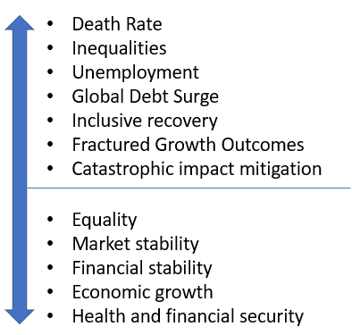 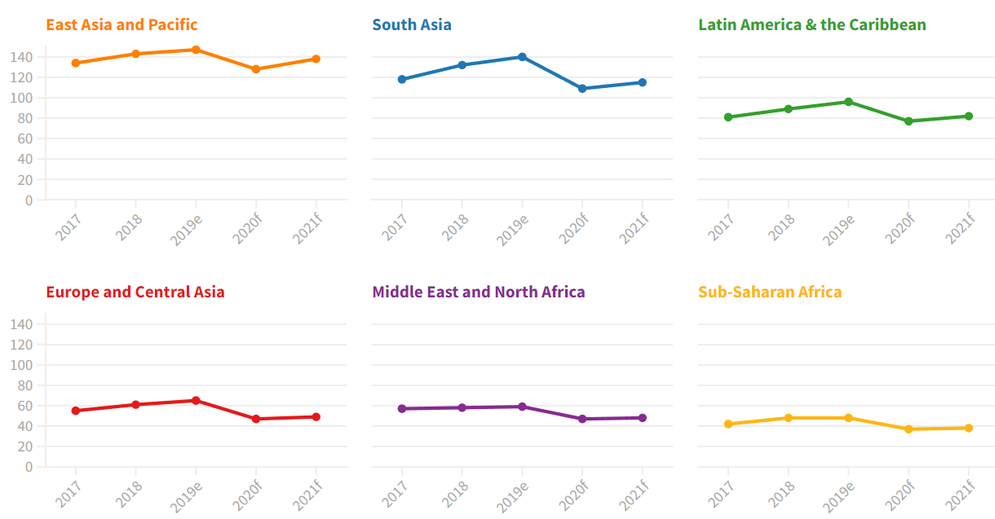

**INDUSTRY OVERVIEW**

The pandemic skewed the energy consumption patterns. Despite drop in consumption, crude price remained high. Global refining margins continued to be at unsustainably low levels. India is the third largest consumer of energy. Conventional sources of energy remain the primary contributor despite the shift towards renewable energy sources. Share of coal is over 50% and Oil and Gas 36%. Oil steals the show not only as an energy source, but also as the only cost-effective source of petrochemicals in the world today. Estimates suggest that the demand for oil and gas in India is expected to grow until 2040.

**MARKET**

The year 2020-21 was the most volatile financial year for International Oil Markets. More work-from-home and lesser business travel lowered the demand. The average Crude Oil Basket price in India fell below USD 20/bbl in April 2020. India utilised this period to fill up its strategic reserves. It helped the country’s current account deficit and saved foreign exchange.

Crude Oil price rose above USD 65/bbl in the last quarter of FY 20- 21 which was not completely demand driven. Refiners suffered from huge inventory losses. Indian refiners and factories were running at low capacities to supply essential fuels. Sales of other fuels was challenging and most of the fuel margins were negative. The product cracks were depressed and the benchmark GRM was negative for the first half of FY 2020-21. Capacity utilization increased in the second half of the year.

**CRUDE BASKET**

Crude requirements were met from various National Oil Companies of exporting countries on term basis and from open market on spot basis.

* In FY 2020-21, the company procured 11.615 MMT of crude oil of which 9.125 MMT was imported
* Bombay High, Ravva and Mangala of ONGC and Cairn India sourced additional requirements
* Crude oil was imported from Kuwait Petroleum Corporation, Saudi Aramco, Abu Dhabi National Oil Company and SOMO
* MRPL imported crude oil through spot tender to meet the Low Sulphur Heavy Stock (LSHS) and shortfall requirements

**PRODUCTS**

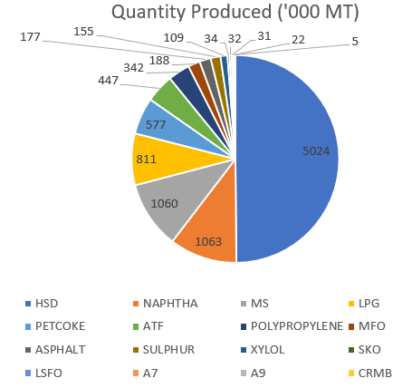 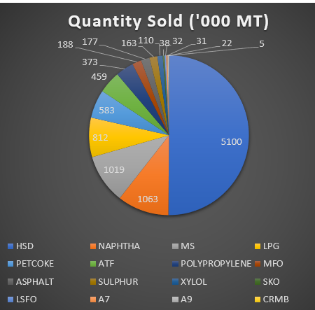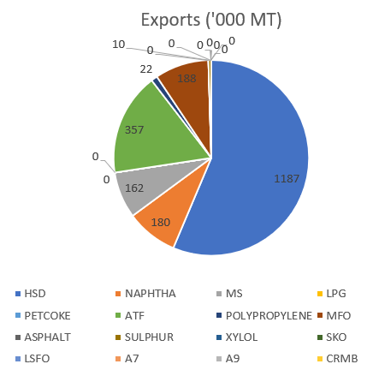

**PERFORMANCE REVIEW**

* MRPL’s performance was severely impacted by the COVID-19 pandemic.
* Reduced demand for transportation fuels
* Demand of ATF dropped to near zero levels and MS and HSD also dropped significantly
* Export demand reduced but domestic LPG and Polypropylene continued to be in demand
* Refinery Capacity Utilization stood at only 60% in the first quarter
* The average Capacity Utilization was 65% for the first 9 months of the financial year. In Jan 2021, the Capacity Utilization reached 100% and continued to remain at 100% for the remainder of the year
* Company’s operating GRM for the Oct- Dec quarter was USD 3.26/bbl and stood at USD 3.71/bbl for the year
* Crude prices rose above USD 65/bbl in the last quarter
* The slowdown period was utilised for maintenance and turnarounds to operate it in full capacity in the new normal
* Commenced installation of a new Oil Marketing Terminal in Bengaluru
* Polypropylene production was sustained at high throughput, as petrochemical returns compensated for the low fuel cracks
* Retail sales are continuously expanded
* Strive for excellence and readiness for normalisation

**RISK MANAGEMENT**

***Crud Supply and Price Risk Mitigation:***

* Operational risks mitigated through operational and marketing plans
* Disruption risks mitigated through multiple sourcing
* Periodic business process optimization review to evaluate economic and performance measurements and actions identified for improvement
* Maintains a cautious inventory of crude to sustain operations without stock out.

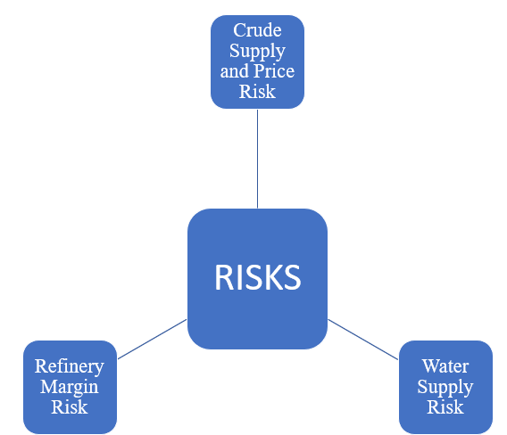

***Refinery Margin Risk Mitigation:*** Volatility is an inbuilt risk for refinery industries. The company disaggregates aspects of the refining supply chain for measuring and improving performance into Crude Supply, Crude Inventory, Refinery Operations, Finished Product Inventory and Product Sales.

* High Asset Utilization is ensured to deliver maximum returns to stakeholder
* State of the art predictive and preventive maintenance and inspection techniques mitigates unscheduled maintenance and shutdowns
* Profitability improvement plans in terms of plant modification and revamps are explored, conceptualized, evaluated, and implemented
* Product value maximization through rugged refinery design with bottom of the barrel upgradation capabilities.
* Merger of OMPL as a fully owned subsidy of MRPL expected to deliver better returns.
* Aromatic and Olefinic production pathwaysexpected to improve versatility and to be an elixir to generate revenue during periods of low demand
* Retail Expansion drive to provide sales margins that would offset the downward pressures on refining margins

***Water Supply Risk Mitigation:*** Asset utilization and the revenues of the organisation provided the road map for desalination plant to meet the refinery’s water requirements.

* Desalination plant is being set up at an installed capacity of 6 MGD.
* The company receives 2-3 MGD of Treated Sewage Water for its operations.
* The Fresh Water footprint is expected to decrease through these strategies.

**FUTURE AHEAD**

Ongoing developmental activities and mitigation strategies of the company are forward looking statements. The company strives to achieve the set targets despite the industry working on a VUCA world. MRPL’s actual results, performance or achievements is thus subject to variations caused by global emergencies, environmental changes, and unprecedented situational variations.

**REPORT SUMMARY**

FY 2020-21 made severe impact on MPRL’s performance for the first quarter. Rising crude oil prices and reduced demand forced the company to concentrate on emergency delivery fuels and shut down its subsidiaries to ensure cash flow. Effective planning and mitigation strategies brought an uptick on the company’s recovery towards the last quarter. MRPL has taken up many actions to consolidate its operations. Fiscal discipline and merger of OMPL with itself were initiated on this regard. While present year performance has been severely impacted on account of the pandemic, the resilience of the company shows that it has the structural capability to withstand and overcome the current short-term crises that is engulfing the whole world.